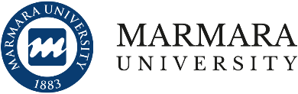
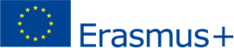
Call for Erasmus+ International Credit Mobility (ICM)

Outgoing Staff Mobility

Project Contract No: 2020-1-TR01-KA107-087815

Application Deadline: 1/12/2022

Application Result Announcement Date: 14/12/2022

​​​​​​​​​​​​​​​​​​​Erasmus+ International Credit Mobility programme enables to exchange staff and faculty members between Nagasaki University of Foreign Studies and Marmara University for teaching mobility activities. This call includes Erasmus+ International Credit Mobility Project, contract no: 2020-1-TR01-KA107-087815.
Teaching mobility – STA
The objective of the mobility is to encourage higher education institutions to broaden and enrich the range and content of courses they offer.

WHO CAN PARTICIPATE?
- Full-time academic staff employed at Nagasaki University of Foreign Studies can apply for staff mobility.
- Applicants are expected to have knowledge of sufficient foreign language to carry out the activity.

DURATION OF MOBILITY
Mobilities will take place in 5 business days (excluding travel days) per staff.
The mobilities shall be completed by February 2023 or an acceptance letter from the partner institution should be submitted to International Office.
A teaching activity has to comprise a minimum of 8 hours of teaching per week.

APPLICATION PROCESS AND TIMINGS
Applications made within the application period (1/12/2022 - 14/12/2022) will be considered and selection will be according to the below criteria.

SELECTION
At the selection stage, the following selection criteria will be taken into account. In case of an equivalency, the preference will go to those who have been selected/invited by the host institution.

1. Job experience at Nagasaki University

a. < 1 year: - point
b. 1- 2 years: 1 point
c. 2-3 years: + 3 points
d. 3-5 years: + 5 points
e. 5-7 years: + 7 points
f. > 7 years: + 9 points

2. International Coordinators at the time of application: + 10 points
3. For each previous participation in the Erasmus+ Staff Mobility within KA107 (Erasmus+ Staff Exchange between Program and Partner Countries): - 5 points
4. Participation in Erasmus programme in the country of nationality: -
5 points 5. Contribution to KA107 project writing process and/or relevance of the project: 0 – 30 points

